EXERCICIOS SOBRE LIMITES:

Calcule os seguintes limites.
1) 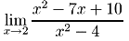
Solução:
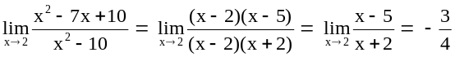

2) 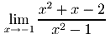
Solução:
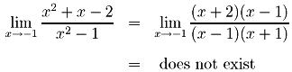

3) 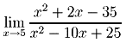
Solução:
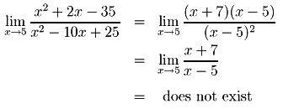

4) 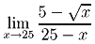
Solução:
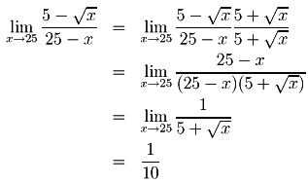

5) 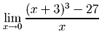
Solução:
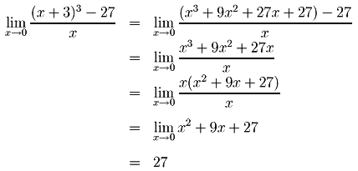
6) 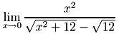
Solução:
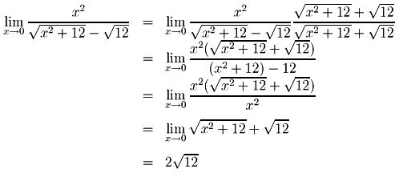

7)Calcule: 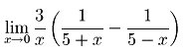
Solução:
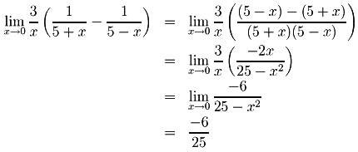
8) Calcule: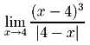
Solução:

9) Calcule: 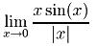
Solução:
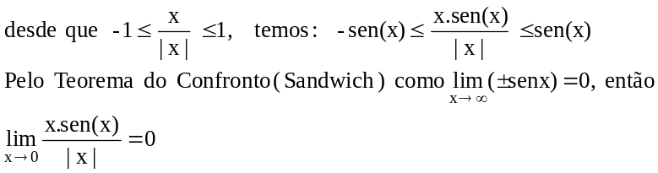
10)Calcule 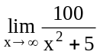
Solução:
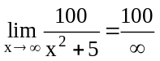
The numerator is always 100 and the denominator x² + 5 approaches as x approaches , so that the resulting fraction approaches 0.

- Calcule 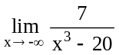.
Solução:
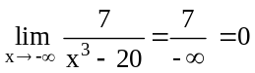

The numerator is always 7 and the denominator x³ – 7 approaches - as x approaches -, so that
the resulting fraction approaches 0.

- Calcule: 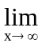 x⁵ – x² + x – 10
Solução:
Note that the expression x⁵ – x² leads to the indeterminate form . Circumvent this by appropriate
factoring:
.
As x approaches , each of the three expressions x², (x³ – 1), and (x – 10) approaches . Temos, então:
“∞.∞+∞”
=
Thus, the limit does not exist. Note that an alternate solution follows by first factoring out , the highest
power of x . Try it.
- Calcule 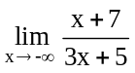
Solução:
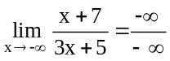

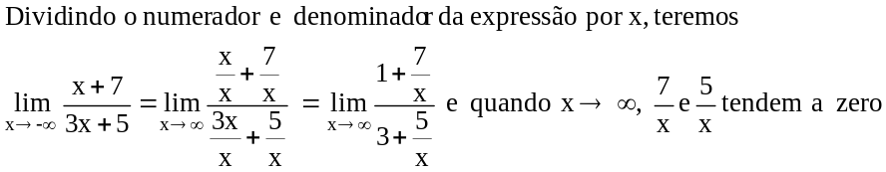

Desta forma, 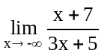 tende a

- Calcule 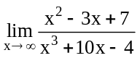
Solução:
Note that the expression x² – 3x leads to the indeterminate form as x se approaches . Circumvent this by dividing each of the terms in the original problem by x³, the highest power of x in the problem .
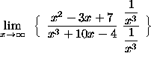
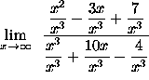
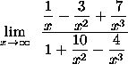
When x the 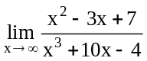approaches 0

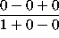
= 0

- Calcule 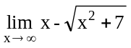
Solução:
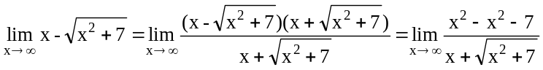=
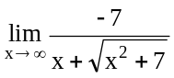 e quando , = tende a zero

- (Circumvent this indeterminate form by using the conjugate of the expression
Calcule 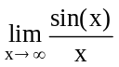

SOLUTION : First note that
because of the well-known properties of the sine function. Since we are computing the
limit as x goes to infinity, it is reasonable to assume that x > 0 . Thus,
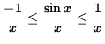.
Since
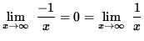,
it follows from the Squeeze Principle that
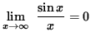
17) Calcule 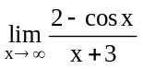
SOLUTION :
First note that
because of the well-known properties of the cosine function. Now multiply by -1, reversing
the inequalities and getting
or
.
Next, add 2 to each component to get
.
Since we are computing the limit as x goes to infinity, it is reasonable to assume that
x + 3 > 0. Thus,
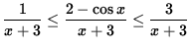.
Since
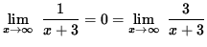,
it follows from the Squeeze Principle that
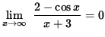.
18) Calcule 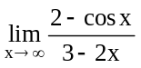

SOLUTION : First note that
because of the well-known properties of the cosine function, and therefore
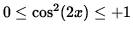.
Since we are computing the limit as x goes to infinity, it is reasonable to assume that
3 - 2x < 0. Now divide each component by 3 - 2x, reversing the inequalities and getting
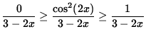,
or
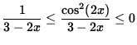.
Since
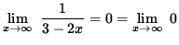,
it follows from the Squeeze Principle that
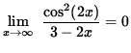
19) Calcule 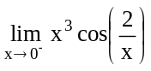

SOLUTION : Note that DOES NOT EXIST since values of 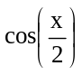oscillate
between -1 and +1 as x approaches 0 from the left. However, this does NOT necessarily mean
that does not exist ! ? Indeed, x³ < 0 and
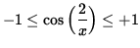
for x < 0. Multiply each component by x³, reversing the inequalities and getting
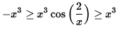
or
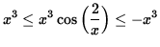.
Since
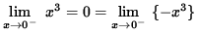,
it follows from the Squeeze Principle that
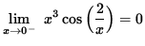.
20) Calcule
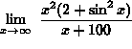.
SOLUTION : First note that
,
so that
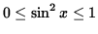
and
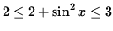.
Since we are computing the limit as x goes to infinity, it is reasonable to assume that
x+100 > 0. Thus, dividing by x+100 and multiplying by x², we get
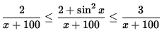
and
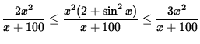.
Then
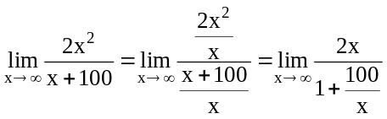 quando x tende a
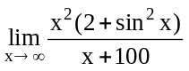 é igual a 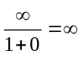

Similarly,
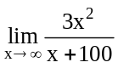= .
Thus, it follows from the Squeeze Principle that
= (does not exist).

21) Calcule
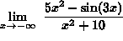.
SOLUTION : First note that
,
so that
,
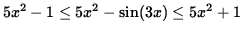,
and
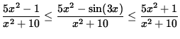.
Then
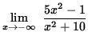
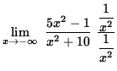
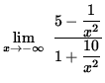
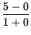
= 5 .
Similarly,
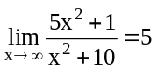
Thus, it follows from the Squeeze Principle that
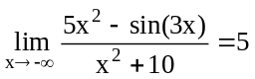 .
22) Calcule
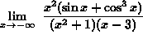

SOLUTION : First note that
and
,
so that
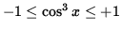
and
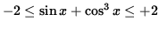.
Since we are computing the limit as x goes to negative infinity, it is reasonable to
assume that x-3 < 0. Thus, dividing by x-3, we get
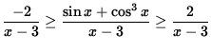
or
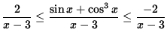.
Now divide by x² + 1 and multiply by x² , getting
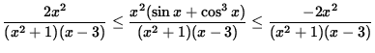.
Then
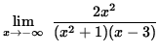
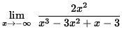

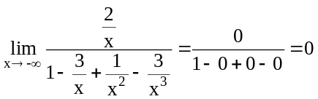

Similarly,
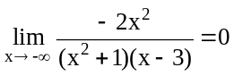
It follows from the Squeeze Principle that
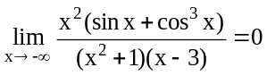

LIMITES – CONSTINUIDADE

- Determine se a seguinte função é contínua em x=1 .
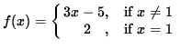
SOLUTION :: Function f is defined at x = 1 since
i.) f(1) = 2 .
The limit
= 3 (1) - 5
= -2 ,
i.e.,
ii.) 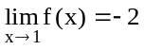.
But
iii.) 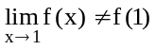,
so condition iii.) is not satisfied and function f is NOT continuous at x = 1.

- Determine se a seguinte função é contínua em x = -2 .
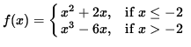
SOLUTION : Function f is defined at x=-2 since
f(-2) = (-2)² + 2(-2) = 4-4 = 0 .

The left-hand limit
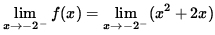
= (-2)² + 2(-2)
= 4 - 4
= 0 .
The right-hand limit
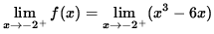
= (-2)³ - 6(-2)
= -8 + 12
= 4 .
Since the left- and right-hand limits are not equal, ,
ii.) 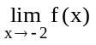 does not exist,
and condition ii.) is not satisfied. Thus, function f is NOT continuous at x = -2 .

- Determine se a seguinte função é contínua em x = 0 .
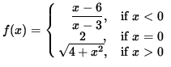
SOLUTION : Function f is defined at x = 0 since
i.) f(0) = 2 .
The left-hand limit
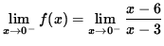
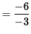
= 2 .
The right-hand limit
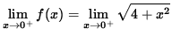
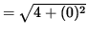
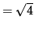
= 2 .
Thus, 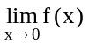 exists with
ii.) 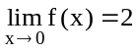.
Since
iii.) 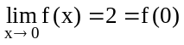,
all three conditions are satisfied, and f is continuous at x=0 .

- Determine se a função 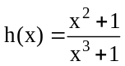 é contínua at x = -1 .
SOLUTION : Function h is not defined at x = -1 since it leads to division by zero.
Thus, h (-1) does not exist, condition i.) is violated, and function h is NOT continuous
at x = -1 .

- Check the following function for continuity at x = 3 and x = -3 .
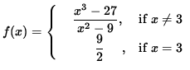
SOLUTION : First, check for continuity at x=3 . Function f is defined at x=3 since
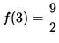.
The limit
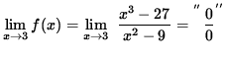
(Circumvent this indeterminate form by factoring the numerator and the denominator.)
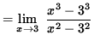
(Recall that A² - B² = (A - B)(A + B) and A³ - B³ = (A - B)(A² + AB + B² ) . )
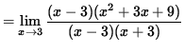
(Divide out a factor of ( x - 3) . )
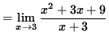
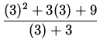
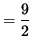,
i.e.,
ii.) 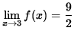.
Since,
iii.) 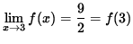,
all three conditions are satisfied, and f is continuous at x=3 . Now, check for continuity at
x = -3 . Function f is not defined at x = -3 because of division by zero. Thus,
i.) f(-3)
does not exist, condition i.) is violated, and f is NOT continuous at x = -3 .

- Para que valores de x a função é 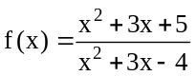contínua ?
SOLUTION 6 : Functions y = x² + 3x + 5 and y = x² + 3x - 4 are continuous for all
values of x since both are polynomials. Thus, the quotient of these two functions,
, is continuous for all values of x where the denominator,
y = x² + 3x - 4 = (x - 1)(x + 4) , does NOT equal zero. Since (x - 1)(x + 4) = 0 for x = 1
and x = -4 , function f is continuous for all values of x EXCEPT x = 1 and x = -4 .

- Para que valores de x a função é 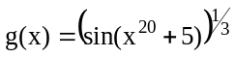contínua ?
SOLUTION: First describe function g using functional composition. Let f(x) = x^{1/3} ,
h(x) = sin(x), and k(x) = x²⁰ + 5 . Function k is continuous for all values of x since it is a
polynomial, and functions f and h are well-known to be continuous for all values of x .
Thus, the functional compositions
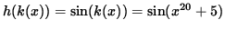
and
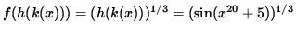
are continuous for all values of x . Since
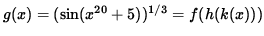,
function g is continuous for all values of x .

- Para que valores de x a função é 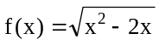contínua ?

SOLUTION : First describe function f using functional composition. Let g(x) = x² - 2x
and h(x) = 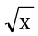. Function g is continuous for all values of x since it is a polynomial, and
function h is well-known to be continuous for 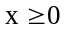. Since g(x) = x² - 2x = x(x-2) , it
follows easily that 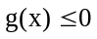for 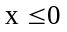and . Thus, the functional composition
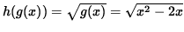
is continuous forand and. Since
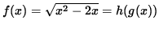,
function f is continuous for and and.

- Para que valores de x a função é 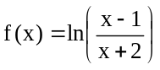 contínua ?
SOLUTION : First describe function f using functional composition. Let
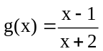and h(x) = ln(x). Since g is the quotient of polynomials y = x - 1 and
y = x + 2 , function g is continuous for all values of x EXCEPT where x+2 = 0 , i.e.,
EXCEPT for x = -2 . Function h is well-known to be continuous for x > 0 . Since
, it follows easily that g(x) > 0 for x < -2 and x > 1 . Thus, the functional
composition
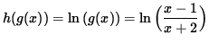

is continuous for x < -2 and x > 1 . Since
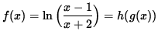,
function f is continuous for x < -2 and x > 1 .

- Para que valores de x a função é 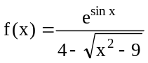 contínua ?
SOLUTION 10 : First describe function f using functional composition. Let
g(x) = sin(x) and h(x) = e ^{x} , both of which are well-known to be continuous for all
values of x . Thus, the numerator y = e^{sin(x)} = h(g(x)) is continuous (the functional

composition of continuous functions) for all values of x . Now consider the denominator
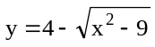. Let g(x) = 4 , h(x) = x² - 9 , and 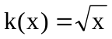. Functions g and h
Are continuous for all values of x since both are polynomials, and it is well-known that
function k is continuous for 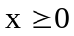. Since h(x) = x² - 9 = (x-3)(x+3) = 0 when x = 3 or
x = -3 , it follows easily that 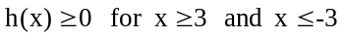 for and, so that
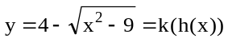is continuous (the functional composition of continuous
functions) for 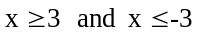and. Thus, the denominator is
continuous (the difference of continuous functions) for and. There
is one other important consideration. We must insure that the DENOMINATOR IS
NEVER ZERO. If
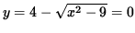
then
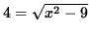.
Squaring both sides, we get
16 = x² - 9
so that
x² = 25
when
x = 5 or x = -5 .
Thus, the denominator is zero if x = 5 or x = -5 . Summarizing, the quotient of these
continuous functions, , is continuous for
and, but NOT for x = 5 and x = -5 .
Para que valores de x é a seguinte função contínua ?
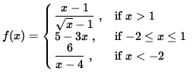
SOLUTION : Consider separately the three component functions which determine f .
Function 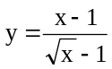is continuous for x > 1 since it is the quotient of continuous
functions and the denominator is never zero. Function y = 5 -3x is continuous for
since it is a polynomial. Function 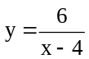is continuous for x < -2 since it
is the quotient of continuous functions and the denominator is never zero. Now check for
continuity of f where the three components are joined together, i.e., check for continuity at
x = 1 and x = -2 . For x = 1 function f is defined since
i.) f(1) = 5 - 3(1) = 2 .
The right-hand limit
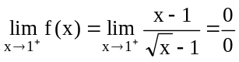
(Circumvent this indeterminate form one of two ways. Either factor the numerator as the
difference of squares, or multiply by the conjugate of the denominator over itself.)
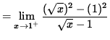
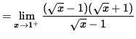
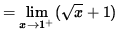
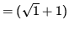
= 2 .
The left-hand limit
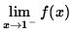= 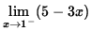
= 5 - 3(1)
= 2 .
Thus,
ii.) 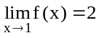.
Since
iii.) = f(1),
all three conditions are satisfied, and function f is continuous at x = 1 . Now check for
continuity at x = -2 . Function f is defined at x = -2 since
i.) f(-2) = 5 - 3(-2) = 11 .
The right-hand limit
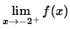= 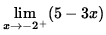
= 5 - 3( -2)
= 11 .
The left-hand limit
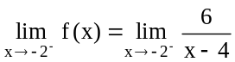=
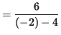
= -1 .
Since the left- and right-hand limits are different,
ii.) 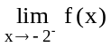 does NOT exist,
condition ii.) is violated, and function f is NOT continuous at x=-2 . Summarizing,
function f is continuous for all values of x EXCEPT x = -2 .

- Determine todos os valores da constante A para que a seguinte função seja contínua para todos os valores de x .
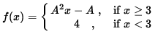
SOLUTION : First, consider separately the two components which determine function f .
Function y = A² x - A is continuous for 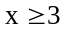 for any value of A since it is a polynomial.
Function y = 4 is continuous for x < 3 since it is a polynomial. Now determine A so that
function f is continuous at x=3 . Function f must be defined at x = 3 , so
i.) f(3)= A² (3) - A = 3 A² - A .
The right-hand limit
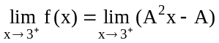
= A² (3) - A
= 3 A² - A .
The left-hand limit
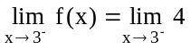= 4 .
For the limit to exist, the right- and left-hand limits must exist and be equal. Thus,
ii.) 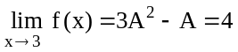,
so that
= 3 A² - A - 4 = 0 .
Factoring, we get
(3A - 4)(A + 1) = 0
for
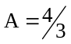 or A = -1 .
For either choice of A ,
iii.) ,
all three conditions are satisfied, and f is continuous at x = 3 . Therefore, function f is
continuous for all values of x if or A = -1 .

- Determine todos os va;ores das constantes A e B para que a função seja contínua para todos os valores de x .
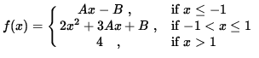
SOLUTION : First, consider separately the three components which determine function f .
Function y = Ax - B is continuous for for any values of A and B since it is a
polynomial. Function y = 2x² + 3Ax + B is continuous for for any values of A
and B since it is a polynomial. Function y = 4 is continuous for x > 1 since it is a polynomial.
Now determine A and B so that function f is continuous at x=-1 and x=1 . First, consider
continuity at x = -1 . Function f must be defined at x = -1 , so
i.) f(-1)= A(-1) - B = - A - B .
The left-hand limit
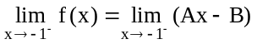=
= A (-1) - B
= - A - B .
The right-hand limit
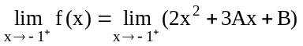=
= 2(-1)² + 3A(-1) + B
= 2 - 3A + B .
For the limit to exist, the right- and left-hand limits must exist and be equal. Thus,
ii.) 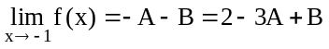,
so that
2A - 2B = 2 ,
or
(Equation 1)
A - B = 1 .
Now consider continuity at x=1 . Function f must be defined at x=1 , so
i.) f(1)= 2(1)² + 3A(1) + B = 2 + 3A + B .
The left-hand limit
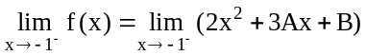=
= 2(1)² + 3A(1) + B
= 2 + 3A + B .
The right-hand limit
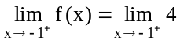=
= 4 .
For the limit to exist, the right- and left-hand limits must exist and be equal. Thus,
ii.) 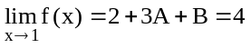,
or
(Equation 2)
3A + B = 2 .
Now solve Equations 1 and 2 simultaneously. Thus,
A - B = 1 and 3A + B = 2
are equivalent to
A = B + 1 and 3A + B = 2 .
Use the first equation to substitute into the second, getting
3 (B + 1 ) + B = 2 ,
3 B + 3 + B = 2 ,
and
4 B = -1 .
Thus,
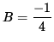
and
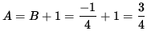.
For this choice of A and B it can easily be shown that
iii.) 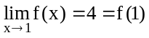
and
iii.) 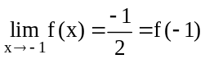,
so that all three conditions are satisfied at both x=1 and x=-1 , and function f is continuous at
both x=1 and x=-1 . Therefore, function f is continuous for all values of x if
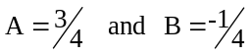and.

